**Lecture1:**

# Laboratory Equipments

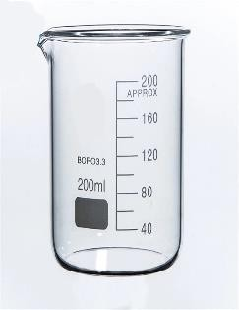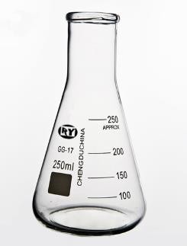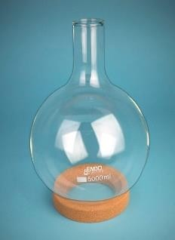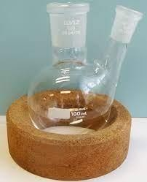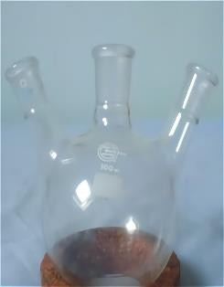

**Beaker Erlenmeyer flask Florence flask Flask boiling round bottom**

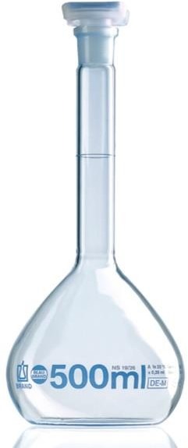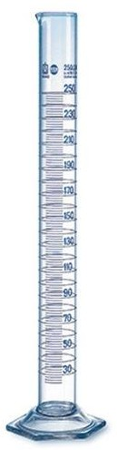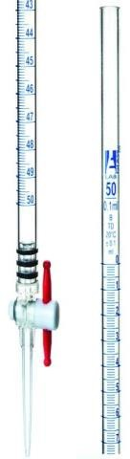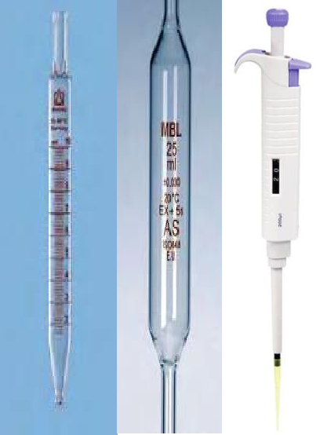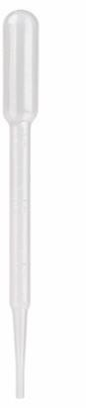

**Volumetric flask Graduated cylinder Buret pipets: graduated, volumetric, micro-**

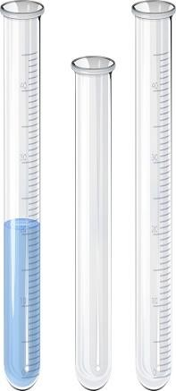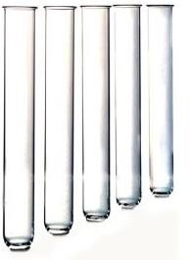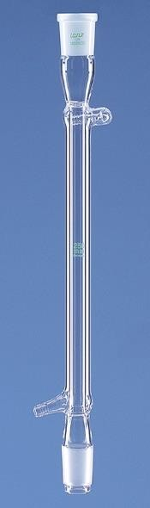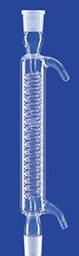

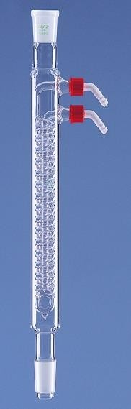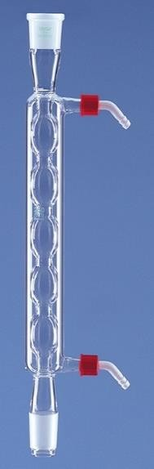

**Test tubes Condenser : Dimroth Allihn Liebig Graham**

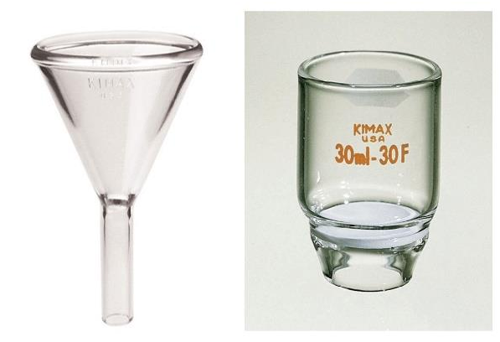 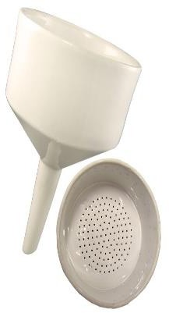 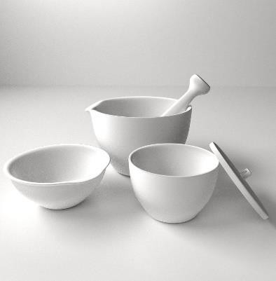

**Glass funnel Gooch filtering crucible Porcelain filter Mortar & crucible**

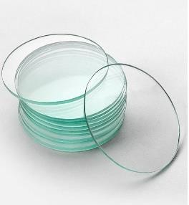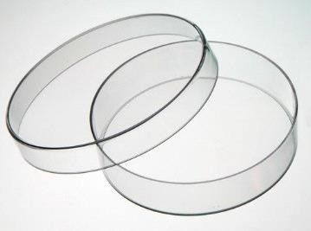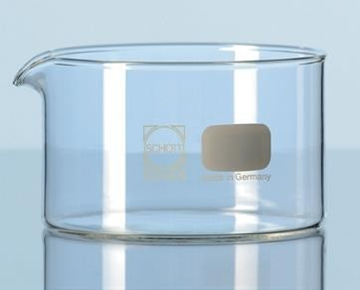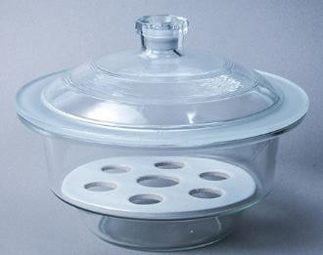

# Watch glasses Petri dish Crystallizing dish Desiccator

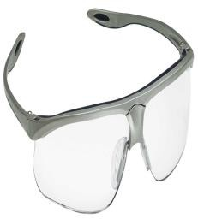

**Lab coat Safety gloves Oven gloves Safety glasses**

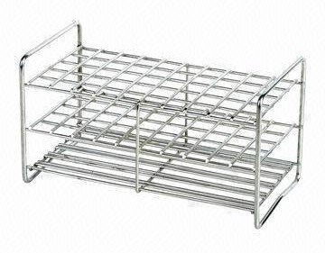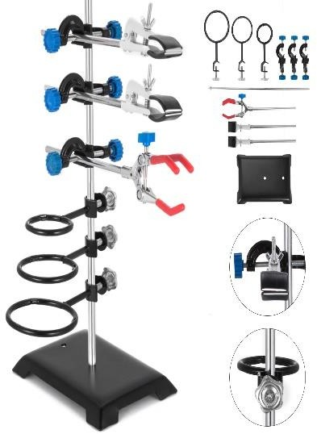

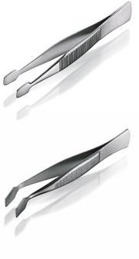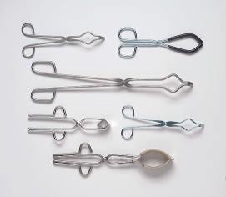

# Test tube track Forceps Tongs Lab Stand

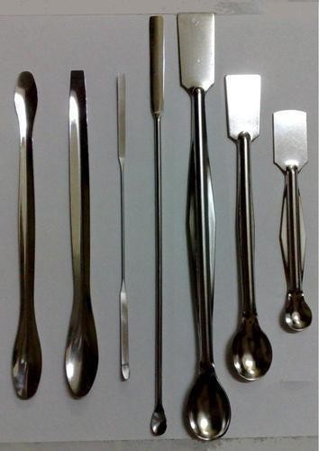 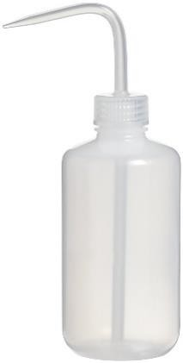 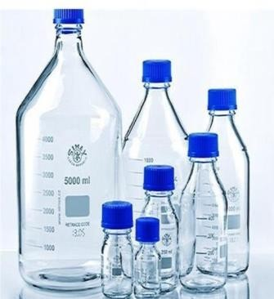 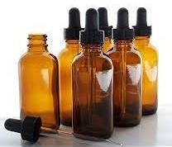

**Micro spoon spalula wash bottle reagent bottle Amber glass bottle**

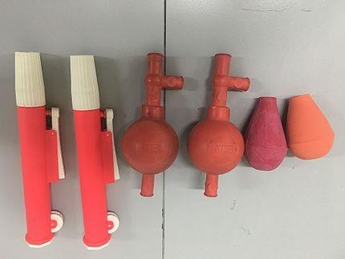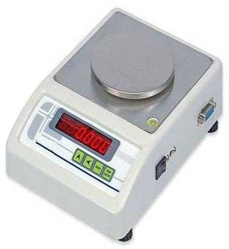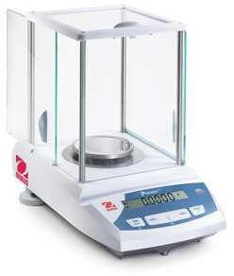

**Safety bulb pump Precision weighing scale High precision weighing scale**

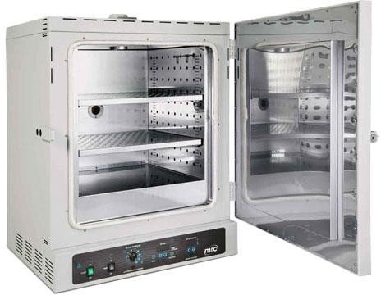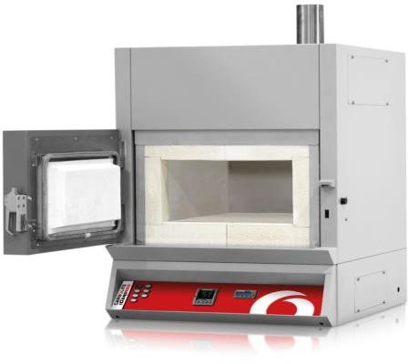

# Drying oven Calcination oven

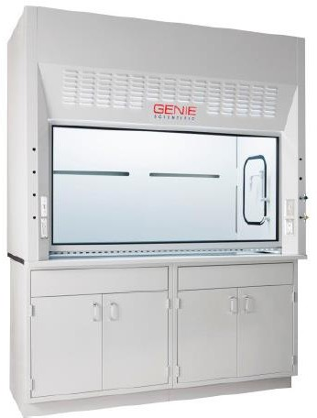

**Fume hood**

# Measurement Science and Technology

**2. 1. Introduction**

Every field of science involves taking measurements, understanding them, and communicating them to others. In other words, we all have to speak the same basic language. Whether you are a chemist, a physicist, a biologist, an engineer, or even a medical doctor, you need a consistent way of communicating size, mass, shape, temperature, time, amount, energy, power, and speed.

# 2. 2.The metric System

The **SI system**, also called the metric system, is used around the world.

There are seven basic units in the **SI system**: the meter (**m**), the kilogram (**kg**), the second (**s**), the kelvin (**K**), the ampere (**A**), the mole (**mol**), and the candela (**cd**).

|  |  |  |  |  |
| --- | --- | --- | --- | --- |
| **Unit name** | **Unit symbol** | **Quantity name** | **Quantity symbol** | **Dimension symbol** |
| **meter** | m | length | *l*, *x*, *r* | L |
| **kilogram** | kg | mass | *m* | M |
| **second** | s | time | *t* | T |
| **ampere** | A | electric current | *I* | I |
| **kelvin** | K | thermodynamic temperature | *T* | Θ |
| **candela** | cd | luminous intensity | *Iv* | J |
| **mole** | mol | amount of substance | *n* | N |

There are **20 accepted prefixes**. A prefix may be used to identify multiples of the original unit or fractions of the original unit. For example, *kilo-* denotes a multiple of a thousand, so there are one thousand meters in a kilometer. *Milli-* denotes a thousandth; therefore, there are one thousand millimeters in a meter.

Keep in mind that prefixes should never be combined. Thus a millionth of a meter is a *micrometer*, not a millimillimeter, and a millionth of a kilogram is a *milligram*, not a microkilogram.

In older usage, a micron (a measurement often encountered in physics and engineering) is the same as a micrometer, 10-6 meters. Another older form of usage, the millimicron, is one thousandth of a micrometer, or 1 thousandth of 10-6 meters, or 10-9 meter, now called a nanometer. While these older terms are not in common usage, they are often encountered in older publications, and knowing their modern equivalents is an advantage.

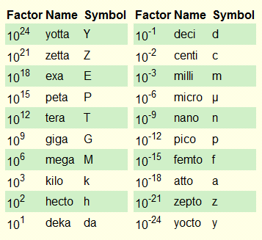

# 2. 3. Physical quantities

Physical quantity is a physical property that can be quantified. Examples of physical quantities are mass, amount of substance, length, time, temperature, electric current, light intensity, force, velocity, density, and many others.

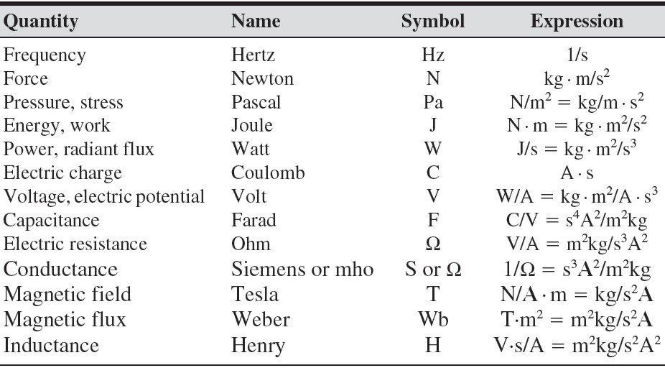

# 2. 4. Chemical quantities

The quantities commonly encountered in chemical problems include the number of moles of a substance; the number of atoms, molecules, or formula units of a substance; and the mass in grams. These quantities are related and can be readily interconverted with the aid of the molar mass and Avogadro’s number.

# Translation

|  |  |  |
| --- | --- | --- |
| **English** | **French** | **Arabic** |
| **Length Height Width Depth Size**  **Dimension Thickness Volume Mass pressure Heat Temperature Atom**  **Molar mass Time**  **....................** | longueur hauteur largeur profondeur taille  taille épaisseur Volume Masse pression Chaleur Température Atome  Masse molaire Temps  …………… | **الطول االرتفاع العرض العمق**  **سمك**  **الحجم**  **الكتلة**  **الضغط حرارة**  **درجة الحرارة**  **درة**  **الكتلة المولية**  **الزمن**  **……………** |